Project Design Phase
Solution Architecture

Date | 12 February 2026
Team ID | LTVIP2026TMIDS35897
Project Name | BookNest : where stories nestle
Maximum Marks | 4 Marks

Solution Architecture:
Solution architecture for BookNest bridges the gap between user needs (online book purchasing) and the technical implementation using the MERN stack.
Goals of the Architecture:
- Provide a secure and scalable online bookstore solution.
- Clearly define frontend, backend, database, and security layers.
- Ensure smooth communication between React frontend and Express backend.
- Enable cloud-based deployment for global accessibility.
- Maintain high performance, security, and reliability.

Example - Solution Architecture Diagram:
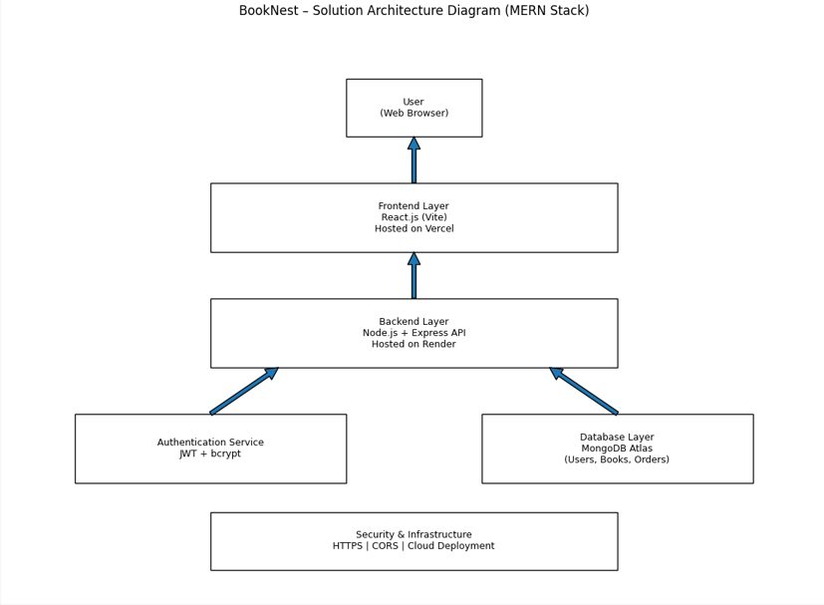
Figure 1: Architecture and data flow of the BookNest sample application
Reference: https://aws.amazon.com/blogs/industries/voice-applications-in-clinical-research-powered-by-ai-on-aws-part-1-architecture-and-design-considerations/

